Darlington Association
on Disability

Centre for Independent Living

Breaking through Barriers

Impact Report April 2014- March 2015

Darlington Association on Disability is an organisation led by disabled people, which exists to promote independence and choice.

DAD supports disabled people and carers through the provision of services, support and information and by tackling issues affecting disabled people both locally and nationally.

Chair’s Report to Members 2014 - 2015

Welfare reforms as well as national and local cutbacks have continued to bring negative impacts to disabled people and carers lives. Disabled people and carers are going through extremely difficult and worrying times and with this the demands on Darlington Association on Disability’s (DAD) services have increased.
These are also worrying times for DAD, with demands on services increasing as financial support is getting more and more competitive and harder to come by. However as a leading disability user led organisation the Trustees and Management of DAD are committed to continue supporting disabled people and carers in the many ways it does.
The funding for Shopmobility was lost completely and it is a constant struggle to maintain this service that is so vital to many peoples independence. Nevertheless DAD is determined not to let this valuable service fold and I thank all who have worked so hard to keep it going.
The demand for funding has increased with fewer funders in a position to meet that demand. I cannot overstate how appreciative I am to all our financial supporters, especially in these times of uncertainty, and offer them my sincere thanks.
I express my immense gratitude to the staff and volunteers of DAD for their loyalty, dedication and tremendous hard work with many going that extra mile as demand for services increased.
I acknowledge the roles played by Chief Executive Lauren Robinson and Senior Managers, Tracy Roberts and Rosemary Berks, in doing an outstanding job in extremely difficult times by continuing to make DAD an organisation that is envied by other towns, and I offer them all my heartfelt thanks.
Finding skilled people willing to give their time to be a Trustee and Director of organisations like DAD is particularly difficult and I cannot express my gratitude enough to my fellow trustees and offer them my sincere thanks for their commitment and hard work that often goes unseen by most.
Gordon Pybus
Chairman
Darlington Association on Disability
Advocacy

DAD supports disabled people and carers to say what they want, secure their rights and get services that they need. DAD also encourages self-advocacy.
Examples of our work in this area include:

- Running and developing the DAD Advocacy Project, bringing together an experienced team of advocates and supporting many people through an increasing number of referrals. In particular, this year DAD has had a strong presence in supporting people in care home settings who are deprived of their liberty under the Mental Capacity Act.
- Supporting People’s Parliament to have a strong voice to influence and shape support and raise issues which affect the lives of people with a learning impairment. This has included highlighting and raising awareness of the transforming Care Agenda, transport and employment.
- Encouraging people at the Independent Living Hub to improve confidence-building skills as a step towards using their experience positively
- Supporting disabled people in preparation for and attendance at Health and Social Care reviews.
- Working with disabled people and parents of disabled children to ensure their views are included in the assessment process
- Supporting people to challenge financial decisions made during the assessment process which impact on their ability to live independently
- Supporting people to challenge discrimination
- Providing rights based information and support to enable disabled people and carers to self-advocate
- Developing and maintaining a confidential database to allow the storing of information securely.
- Training new and existing Advocacy Project staff, as well as staff and volunteers from other projects, including training on the Care Act 2014.
- Accepting an increasing number of referrals for independent advocacy with changes in recent legislation around social care meaning representation is becoming more prevalent for individuals and social work professionals.
- Drawing on expertise from the wide range of experiences within DAD to provide independent representation and support
- Designing and delivering sessions on Self-Advocacy with People’s Parliament.

‘Advocacy is about enabling every person to have a voice of their own and ensuring that they are not excluded because they do not express their views in ways that people understand’ (A voice of their own, BILD, 2006)
Access

DAD brings disabled people together to improve access by addressing barriers created by both the physical and attitudinal environment. It does this by promoting good practice around access issues, and by working with planners and providers to improve access to services. DAD also advises public bodies how to carry out the duties imposed on them by the Equality Act.

Examples of our work in this area include:

- Working with the council in design proposals for widening pavement areas and moving bus stops around the Town Hall, advising on drop kerbs, ramps and parking arrangements. Updating a disability access audit of the Town Hall.

- Working with local businesses to improve their access and services for disabled people

- Advising on planning applications

- Raising alerts on obstructions around the town, such as unlicensed scaffolding that doesn’t comply with legislation or blocked pavement access, both dangerous for people with visual impairments.
- Supporting people to understand rights and legal issues around access to challenge decisions such as supporting someone from North Yorkshire to challenge their council on A-boards.
- Assessing wheelchair accessible taxis to ensure the correct equipment is available and being correctly used.
- Hosting a consultation on NHS Accessible Information Standard
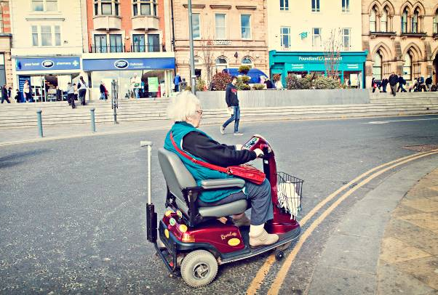

Campaigning

DAD is a non-political organisation; however it actively campaigns on issues which affect the lives of disabled people, families with disabled children and carers. DAD listens to its members and tries to influence decisions that are being made at a local and national level. Some examples of our work in this area are:

- Co-ordinating responses and getting people involved in various public consultations

- Gathering evidence and making the Council and other public bodies aware of the impact of the cuts on disabled people and carers.

- Supporting young people to speak out about issues that affect them.

- Campaigning at a local and regional level for improvements in the way that disabled people who are the victims of hate crime are supported.

- Releasing statements and articles on issues faced by disabled people and carers, for example transport issues.

- Supporting individuals to appeal and challenge decisions such as being refused a blue badge.

“I personally would not have managed without the help I have received in the past and present and it is more than likely I will be needing their help in the future, and I know they will be there.”

‘I cannot think of any way the service can be improved. I think it is marvelous, it is greatly appreciated our lives have improved dramatically’

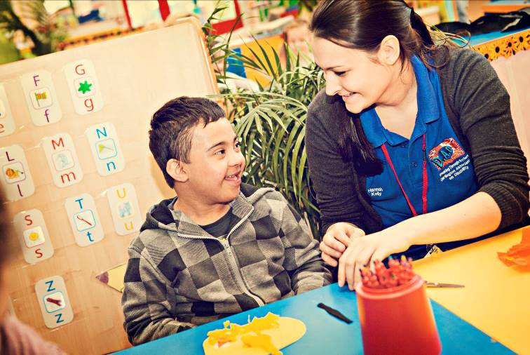
Peer Support

DAD offers opportunities for disabled people of all ages and carers to learn from one another, and to work together to tackle issues. This is called peer support.

Examples of our work include:

- Facilitating a number of groups for carers, who are often isolated by their caring role, bringing people with similar experiences together.

- Organising Health and Wellbeing days for Parent Carers with therapies and group sessions where parents shared their personal experiences.

- Bringing people who use Direct Payments together for peer support in a regular monthly group meeting, enabling them to share experiences and influence service development.

- Recruiting young disabled people as volunteers on DAD’s playschemes, enabling them to develop skills as peer mentors and providing disabled children with positive role models.

- Enabling members of the Independent Living Hub to support each other to build confidence and find solutions to barriers which impact on their independent living.

- Running a Young Leaders group which enables young disabled people aged 14-25 to develop confidence and skills and gives young people a voice.

- This year has been the third and final year of our Stronger Voices…Strong Support project, funded by the Department of Health Development Fund. The project has enabled further development of peer support through support planning and personal budget process. The project is being independently evaluated.

“Knowing there are others like me who have a relative with mental health problems makes all the difference”

“You never just get left to cope on your own once you’ve asked for help; most of the time they go above and beyond what other organisations would do. They keep in constant contact and always check if you’re doing OK and are coping with everything.”

User Led

DAD is a disabled peoples user led organisation (DPULO) which is run and controlled by people with lived experience of disability, it includes people of all ages, people who experience mental ill health, people with learning impairments and their families and carers. This is fundamental to the way that DAD works, as it means that people who DAD supports direct and influence the organisation at all levels.

In order to meet this vision DAD:

- Is committed to develop policies which actively support the recruitment and retention of disabled people and carers as staff and volunteers

- Has retained a longstanding commitment to being user-led. It has developed from a small charity led by disabled people, to a company limited by guarantee with a Board of Trustees, the majority of who are disabled people

- Works with young people to produce leaders of the future; supporting them to get involved at all levels within DAD – as volunteers, staff and Trustees.

- Facilitates a Stakeholder Forum where any member of DAD can raise issues of concern and consulting widely with our members

- Delivers training through projects, with staff and volunteers who themselves have planned their own support and therefore have first-hand experience

- Involves disabled people in recruitment and selection decisions.

- Designs programmes of activities based on evaluations and suggestions from people who use DAD.

“A ULO is an organisation based on clear values of independence, involvement and peer support. Unlike other voluntary sector organisations, service users control the organisation. ULOs are uniquely identified by their knowledge, which is based on direct, lived experience. These three criteria define a ULO” (Shaping Our Lives 2009)

Co-production

DAD supports and encourages co-production, ensuring that disabled people and carers are involved fully and at the earliest possible opportunity when policies or services are being developed.

Co-production refers to a way of working where decision-makers and disabled people and, or, carers work together to make a decision or develop a service which works for everyone. Co-production is built on the principle that those who are affected by a service are best placed to help design it.

Examples of co-production include:

- Supporting the further development of a local Parent Carer Forum, ensuring parents voice influences the introduction of the Children and Families Act 2014, and education reforms.

- Working with the People’s Parliament to enable people with learning impairments to develop skills which they can use to co-produce local services, delivering training to health facilitators and getting involved in consultations.

- Supporting carers who sit on the Carers Strategy Steering Group, which determines how services for carers are developed and delivered in Darlington

- Ensuring that the ethos of the Co-production model is firmly embedded in our partnership with Darlington Borough Council as a way to effectively develop personalisation locally

- Ensuring that parents of disabled children have opportunities to influence the development of the local Special Educational Needs (SEN) reforms.

- Working with parents and carers to gather views about Speech and Language Service and Home to School Transport and how they can better meet the needs of children and young people and their parents and carers.

- Involving disabled people in the design of new buildings and in planning forums where they can influence decisions about access and service delivery

“I now have more confidences to talk to Doctors and consultants. I have realised that I am the professional in my caring role, not them.”
Training

DAD organises and offers training on a wide range of topics to practitioners and advisers, voluntary sector organisations, disabled people and carers. The purpose of training has been twofold – to increase the knowledge and skills of staff and volunteers within DAD in order to deliver the best possible service, and to improve the lives of disabled people and carers by providing them with a range of training.

Examples of training delivered to staff, volunteers and members during the year include:

- Disability Equality and Equality Act
- Care Act 2014
- Keyworking In Participation training for practitioners and parent / carers
- Communication Training
- Office Skills and Administration training
- Telephone and Computer Skills
- Safeguarding training
- Courses for carers health and wellbeing, including sessions on confidence building, managing stress, health checks, relaxation techniques, practical techniques for coping with caring
- Prepare for Work Programme supports carers who want to start or go back to work and retain their skills.
- Carer Awareness training at the local Job Centre
- Mandatory staff training
- Volunteers attend training sessions and shadow project workers at appointments and visits to get hands-on experience.
- Tailored Mentoring For Independence training for young people to learn skills in budgeting, transport, personal care and cooking.
- Inclusive Play training programme planned/co-delivered by Young Leaders
- Accredited training around personalised support for volunteers

”I am pleased that I came on the course, this has helped my confidence and I have found new friendships by participating.”

Personal Budgets and Direct Payments

DAD is committed to disabled people, parents and carers having more choice and control over the assessed services they receive. DAD offers information, advice and support to people to explore and use Personal Budgets, Direct Payments and Personal Health Budgets. Staff can also assist with the self-assessment process and support planning. Some examples of our work are:

- Running a full payroll service and a robust recruitment service, supporting people with Direct Payments to advertise, vet and recruit and employ their own Personal Assistants

- Operating managed accounts that provide an opportunity for people to
have a direct payment without the additional responsibilities of managing their finances

- Supporting direct payment users to pool budgets and share support. This can be a great way to get the most out of a direct payment, for example: forming a sports or social group and purchasing equipment, paying for a holiday or short break, going on trips or excursions, or pooling the support from a personal assistant. This also enables people to form new relationships and have new social opportunities.

- Piloting Personal Health budgets across Tees Valley, supporting people with the practicalities of accessing and using a Personal Health budget.

- An audit of the Direct Payment Support Service showed that appropriate and robust systems are in place

- Enabling disabled people and carers to explore imaginative and cost effective ways to receive assessed services. Examples include weekly music sessions at The Forum to learn instruments and socialise with friends, and support to get a laptop for an individual to manage paying personal assistant wages, banking, shopping and socialising.

‘A direct payment allows me the flexibility to choose who looks after my mother while I am at work. I know that she is being cared for on a one to one basis and her individual needs are being met. My lead worker was very knowledgeable about direct payments. They gave me general advice whilst still being sympathetic to my individual and my mother’s needs. Very professional but still very approachable and friendly’

‘It helps that DAD work out all payroll and support received, I couldn’t do it without them’

Choice, Control, Flexibility and Inclusion

As a Centre for Independent Living (CIL) DAD provides unique practical services which enable disabled people and carers gain and maintain control over their lives. People using DAD have access to a wide range of support, including personal assistance, person centred support services, information and advice, co-production and training. Some examples of our work in this area include:

- A ground breaking new partnership with Age UK and Darlington MIND to work with local multi disciplinary teams (MDT’s) to pilot voluntary sector brokerage for people discharged from hospital, supporting them to access a range of voluntary and community support.
- Developing an outreach service so that people can receive support to access independent living, community and leisure facilities. The Independent Living Hub has also expanded to include support outside of the Hub and at evenings and weekends.
- Increasing the range of equipment available through Shopmobility, including short-term and long -term loans.
- Delivering a range of holiday activities through DASH playscheme.
- Offering a wide menu of support to people using direct payments, including a robust recruitment service that helps people advertise for personal assistants.
- Working together to add value to the service we provide. Examples include providing an information service alongside Shopmobility to enable first time customers to explore other sources of support.
- Supporting carers to benefit from a range of creative short breaks, including, wheelchair hire, placements and outreach from the Hub, an overnight stay in a hotel, sports subscriptions, gym membership, film and photography courses, transport to visit relatives in hospital and gardening work.
- Working to enable carers to take another step towards employment through work placements, practical and financial support to attend interviews and targeted training opportunities etc.

“Thank you for all that you guys do. In my role at work I have passed your number to lots of clients, so sorry if this puts a bit of a strain on you, but I just love what you do and want to sing your praises to all.”

“The Hub has given me the chance to access educational programmes, social activities which has improved my communicational skills and life. Instead of being at home it has enabled me to go out more in the community.”
Information and Advice

DAD provides comprehensive, up to date information and advice on a wide range of topics. The organisation also supports disabled people and carers to make informed choices and increase independence through access to disability rights based information.

Some examples of our work in this area are:

- Enabling disabled people to increase their understanding about their rights and how to challenge decisions

- Providing information and advice to people on a wide variety of topics, ranging from independent living, housing, adaptations and equipment, education and welfare rights.

- Working with other local services to deliver information and advice at community events throughout the Borough

- Providing information in a range of formats, including large print and audio versions of the Blue Badge guide, fact sheets and newsletters

- Delivering training to increase staff and volunteer knowledge and understanding, allowing them to pass on more information, including the Care Act, Equality Act, changes to Personal Independence Payment and Disability Living Allowance.

- Supporting people to secure grants, appeal Employment Support Allowance decisions and to challenge reduction of discretionary housing payments, council tax and disability related expenditure

- Establishing new information factsheets and resources that can provide answers to regular enquiries

- Holding information sessions about the implementation of the Care Act and informing people about how they can get involved through consultation to submit their views.

“When I have required information or help, I have always been informed of everything that DAD can help me with and if they get more information they let me know. They put me at ease and I always know they will do their upmost to help, no matter the reason why or what I’ve asked for help with.”
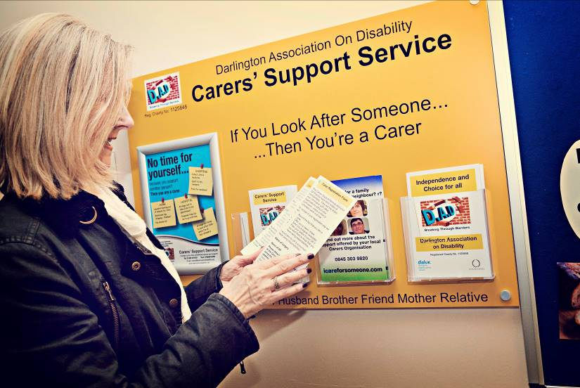

Financial Information
The following figures are taken from the Report of the Trustees and Financial Statements for the year ended 31st March 2015 for Darlington Association on Disability.

Income
The following graph shows the breakdown of Total Income:

Donations £2,890
Activities for generating funds £310,218
Bank Interest £370
Income from Charitable Activities £863,881
Total Income £1,177,359

Financial Information

Expenditure
The following graph shows a breakdown of the Total Expenditure:

Project Costs £1,060,618
Support Costs Management £4,738
Depreciation £7,791
Fundraising & Governance Costs £95,916
Total Expenditure £1,169,063

DAD Services

Access Interest Group brings disabled people together to improve access for disabled people by addressing physical and attitudinal barriers.

Advocacy Project is a free and independent advocacy service for individuals and carers.

Carers’ Support Service provides free information and advice to anyone providing support to a family member, friend or neighbour because of age, illness or impairment.

Children and Young Peoples service (ChYPS), delivering support and activities for play and leisure. Independent Supporters providing advice and information to children, young people and families who have a right to an Education Health and Care (EHC) plan. Continuing Keyworking in Partnership to support participation of children and young people accessing joint support plans. Parents Forum, facilitating opportunities for Parents to identify and influence issues of importance for them and their children.

Direct Payments Support Service provides a range of support about Direct Payments; one way to get more choice and control over social care support.

Information Service provides disability information and advice.

Shopmobility Service provides the loan of manual and electric wheelchairs and mobility scooters in Darlington Town Centre for anyone with mobility impairment.

Volunteer Project recruits and supports volunteers to work in DAD and other organisations.

The Independent Living Hub offers support to disabled people to increase self-confidence and to identify and work towards personal goals. It also offers opportunities to meet new people, experience peer support and take part in a range of social, volunteering and employment opportunities.

Stronger Voices…Strong Support for disabled people who have used personal budgets to support others through advice and guidance, workshops, peer support and mentors.

